**Weekly Assignment 3 - Task models & Personas:**

**Name: Jiahao Wang**

**Partner: Zijun Liu**

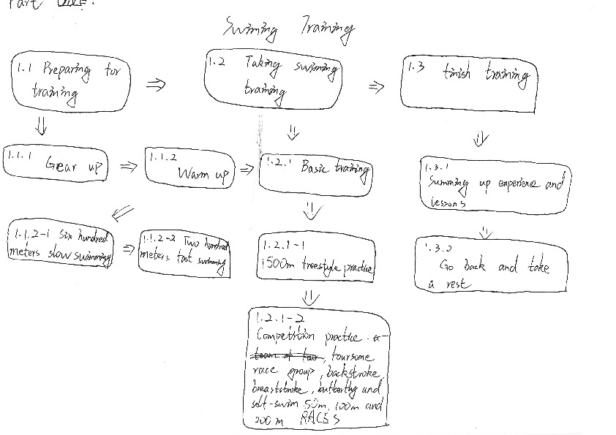

Feedbacks from Zijun Liu:

1. The whole flowchart is not clear enough to summarize every detail

2. Individual examples are not specific enough

Persona 1:

1. Football player.
2. He would like to train with teammates.
3. Joining in parties
4. He would like to work out in gyms

Persona 2:

1. Physics major

2. staying at home

3. playing PC games

4. loving watch cartoon